PERSONA TEMPLATE

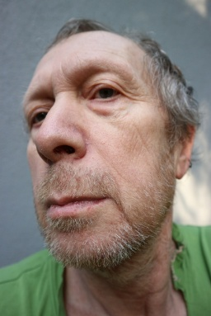 | PERSONA PHOTO |  | GOALS AND MOTIVATIONS |  | CHALLENGES AND OBSTACLES
 |  |  | Order supplies and tools online to save driving time. Find reliable products at fair prices. Have orders delivered to his home or worksite. Wants a straightforward experience with no unnecessary steps. |  | Not very confident with technology and prefers simple interfaces. Doesn't always trust online payment systems. Limited time to browse therefore needs to find what he wants quickly.
QUOTATION
"I just need it to be simple. Tell me what it costs, how long it takes, and I'm done."
NAME
James Taufa
AGE
58 |  |  | FRUSTRATIONS |  | SOURCES OF INFORMATION
GENDER |  |  | Websites with too many pop-ups or confusing layouts. Hard-to-find product descriptions or missing prices. No clear delivery timeframes shown at checkout. Difficulty getting help when something goes wrong with an order. |  | BOOKS
Male |  |  |  |  | Trade manuals and product catalogues
LOCATION |  |  |  |  | BLOGS
Napier, Hawke's Bay, New Zealand |  |  |  |  | Rarely reads blogs; prefers word-of-mouth recommendations
OCCUPATION |  |  |  |  | CONFERENCES
Self-Employed |  |  |  |  | Local business expos and regional trade events
JOB TITLE |  |  |  |  | EXPERTS
Owner/Operator – Small Landscaping Business |  |  |  |  | Trusted suppliers and fellow tradespeople
HIGHEST LEVEL OF EDUCATION |  |  |  |  | MAGAZINES
New Zealand Certificate in Horticulture (Level 4) |  |  |  |  | NZ Lifestyle Block, local community newspapers
ANNUAL INCOME |  |  |  |  | WEBSITES
$48,000 NZD per year |  |  |  |  | MITRE 10, Farmlands, Facebook Marketplace
Image Reference:
Siedlecki, P. (n.d.). Portrait of an old man [Photograph]. Public Domain Pictures. https://www.publicdomainpictures.net/en/view-image.php?image=168895&picture=portrait-of-an-old-man

